The Ethics of Public Health Emergency Preparedness and Response

Experiences and lessons learnt from frontline clinicians in low- and middle-income countries in the Indo-Pacific region during the COVID-19 pandemic

Summary report 31 March 2021

Background

Emergency care (EC) is the multidisciplinary, team-based provision of time-critical clinical interventions to prevent death and disability for all acute and urgent aspects of illness and injury. The Australasian College for Emergency Medicine (ACEM) is the peak body for emergency medicine (EM) in Australia and New Zealand. ACEM’s Global Emergency Care Committee (GECCo) and Global Emergency Care (GEC) desk are committed to improving the capacity of low- and middle-income countries (LMICs) to deliver safe and effective EC, with a focus on the Indo-Pacific region.

The COVID-19 global pandemic has illustrated how public health emergencies stress even mature and seemingly highly developed health and EC systems. Many countries in the Indo-Pacific region have under-developed health systems and limited capacity to provide safe and effective EC.

In rapid response to the pandemic, ACEM’s GECCo hosted regular online forums with health stakeholders across the region to share knowledge, build resources and provide support. In these forums, participants identified local, ethical and clinical challenges. ACEM identified the need to increase understanding of ethical tensions implicit in public health emergencies for EC providers in the Indo-Pacific region, and also identify and share lessons from the COVID-19 pandemic by numerous Pacific Island countries. In collaboration with the SPC and key regional stakeholders, ACEM GECCo conducted research and produced a report to the World Health Organization about ‘The Ethics of Public Health Emergency Preparedness and Response’. This is a summary of the report, which is available in full on the ACEM website: https://acem.org.au/getmedia/b3f78c65-8841-46eb-993b-bbc10dd37594/WHO-Report-R10.

Research aim and design

The research was designed to explore the experiences of EC providers and stakeholders in the Pacific region during the COVID-19 pandemic, with a particular focus on identifying ethical issues. We also identified enablers of, and barriers to, effective EC responses and documented lessons learned to inform recommendations to improve health system preparedness for future public health emergencies.

Rapid qualitative research methods were used to collect and analyse data. Information was gathered from key EC leaders and providers (physicians and nurses) and other stakeholders in Indo-Pacific countries in two phases: via ACEM’s online support forums and through in-depth interviews. In total there were 87 informants: 80 active participants in 13 online support forums (conducted between March and October 2020), and seven selected interviewees (interviewed in February and March 2021). Informants lived and worked in more than 20 countries across the Indo-Pacific region. We analysed the data using the WHO health system building blocks adapted to the Pacific EC context¹ and ethics guidance related to the COVID-19 response².

Research findings

Ethical and clinical challenges

We identified six key themes representing the ethical and clinical challenges in providing safe and effective emergency care during a public health emergency.

Key themes

1. Emergency care responses are limited by underdeveloped, under-prepared and under-resourced health systems.

‘We already operate in a disaster environment … You would rarely have enough equipment, enough wards … we are faced with the critical question every day on who to provide ICU care to.’
2. An effective response is dependent on listening to healthcare workers’ fears and protecting their safety and wellbeing.

3. Emergency departments are unique frontline response areas, required to respond to COVID-19 as well as maintain “business as usual”.

4. Emergency care clinicians are experienced innovators in disaster response and triage, with flexibility and vision under pressure.

‘…sometimes we just had to stand our ground and voice our concerns, just to get everybody else to understand what is happening, and why we’re fighting, in the best interests of the patient. That’s how we developed our systems and our flow charts, and it worked, it’s getting to work now.’

5. Significant ethical challenges occurred for clinical decision-makers in resource-limited environments.

6. Indirect effects and unintended health consequences are associated with the COVID-19 response.

Examples of the ways in which four key ethical principles – autonomy, beneficence, nonmaleficence and justice – were applied, or relate to, decision-making and EC responses to the COVID-19 pandemic also are identified in the report. For example, beneficence was most evident in the commitment of clinicians and HCWs to their duty of care – despite their fear, threats to their personal safety and the safety of their family members, and the many other disincentives to participating in the response.
‘ … it’s important for us all to stand up together and to work together to ensure that we tackle the initial cases well, so that we keep the rest of the community and the country safe as well.’

Barriers and enablers

Identified barriers and challenges to, and enablers and strengths of, EC responses in the Indo-Pacific region are summarised in Table 1. Barriers and enablers were categorised in relation to each of the five Pacific EC Health System Building Blocks: human resources (HR) and training, infrastructure and equipment (including medications), data (information and research), processes, and leadership and governance.

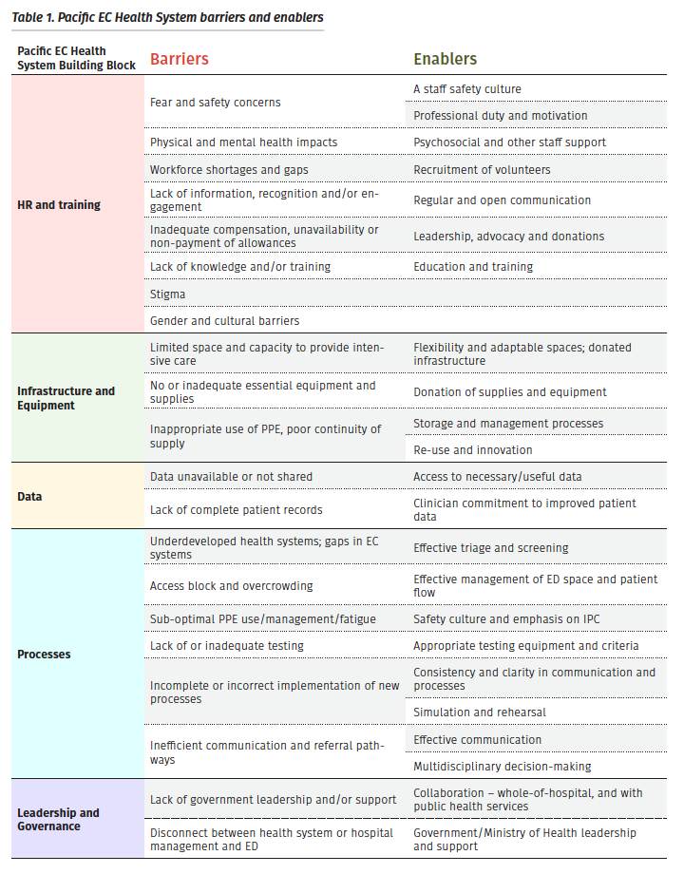

Lessons learnt

Key lessons learnt from responses to the COVID-19 pandemic in Indo-Pacific countries may be valuable to other countries, particularly LMICs, adapting and needing innovative and low-cost strategies to overcome clinical, ethical and limited-resource challenges.

HR and  training | - Moving from fear and panic to confidence and readiness to respond to public health emergencies was enabled by clear and open communication, education, training (including simulations), leadership and peer support.
- HCWs need to feel safe, engaged, valued and protected to overcome fear and reluctance to participate in the public health emergency response.
‘The staff, I think, are potentially one of our biggest problems. They’re really unhappy. They’re frightened. They haven’t been engaged with.’
- Some HCWs will remain resistant and unwilling to work at the frontline; rather than force them to engage in training, it was more effective to focus on protecting and supporting the HCWs who were willing to work in COVID-19 areas.
- Proactive and transparent information-sharing was necessary to empower and engage staff, and dispel COVID-19 myths.
- Securing staff entitlements including appropriate remuneration, risk allowances, income protection and insurance agreements, mental health care, and appropriate accommodation and support for staff quarantine required clinician leadership and advocacy.
‘The staff, we love our job but, we have issues like with our leaders and our salaries and all this. They’re trying to minimise our overtime, which is going to be very hard for us, because when the real crisis will come we will still need to, we will go beyond whatever they limit us to make. But ... the nurses are still complying with our schedule.’
- Continuing education and training was, and will be, necessary to maintain staff safety, reduce the risk of burnout or complacency, and ensure preparedness for future public health emergencies.

Infrastructure  and Equipment | - It was most effective – and safer for staff and patients – to “do the basics well” and not be pressured to implement interventions until there were clear guidelines and staff were trained and comfortable.  ‘In terms of intensive care, I don’t think we’ll be able to do that here. We don’t have ventilators, we don’t have a lot of stuff here.’
- The availability and appropriate use of PPE was key to staff safety (actual and perceived) in managing patients with infectious disease – and required adequate supply, training and support, and ongoing monitoring of practices (donning, wearing and doffing) for all workers.
‘We do have major issue with low PPE supplies due to closed borders. We have ordered PPE and some donations [are] on the way. However, still trying to get them into the country by boat … as flights are still closed.”
- Proper implementation of screening, IPC and diagnostic processes was essential to protect staff (and other patients) from undifferentiated patients presenting at the ED. Having enough space and good design with infrastructure was crucial.
- Having infectious disease screening and isolation facilities separate from the ED prevented further impacts on ED operations
‘Our facilities were not ready, in terms of preparation … we’ve decided that we will handle our COVID patients somewhere outside of the hospital.’

Processes  and Data | - An emergency response plan, clinical guidelines and SOPs are necessary, ideally prepared in advance and country-specific, and need to be properly implemented.  ‘Before they send a case or refer a case whoever is referring will update the ED first, “Look we are sending this case over to you guys and this is what we (referral hospital) have done”. Actually, we don’t have these things as a national guideline. I have created one because at the end of the day the burden comes to us.’
- A whole health system approach and planning is essential, including public health, pre-hospital, ED and inpatient teams. A well-functioning pre-hospital system is necessary to maintain patient care during public health emergencies.
- Settings with more robust emergency care systems were better placed to respond to the pandemic and scale-up their capacity for triage, risk assessment and clinical management. There was an intrinsic link between ‘routine care’ capability and preparedness for public health emergencies.
‘Before COVID we didn’t have any sort of patient flow system if you work here; so it’s like any Tom, Dick and Harry will just come in.’
- Effective IPC precautions (to protect staff and patients), screening processes (to determine transmission risk) and triage systems (to identify urgency and care needs) were key to a safe and effective response to a communicable disease outbreak. It was acknowledged that these processes should be used not only during the COVID-19 pandemic but in routine practice.
- Adequate testing capacity and appropriate testing criteria were necessary to ensure staff safety as well as sustainability long term.
‘That’s the drawback of the system – we’re not actually initiating any responses until we get a positive case. But we won’t know we’ve got a positive case until we’ve tested, and then we’re already looking after them.’

Leadership and  Governance | - Involvement of ED clinicians in response planning and national taskforces helped ensure the incorporation of EC processes and recognition of the burden on EDs at the frontline of the response.  ‘The emergency staff are leading transport. They’re on all the care committees. They’re on the national committee. And they’re actually the people putting forward good evidence-based care. And trying to override political decisions, as opposed to health science decisions.’
- A whole-of-hospital response, along with effective and interdepartmental collaboration and communication, is crucial – and was achievable if the hospital executive demonstrated leadership and engaged all departments.
- Sharing evidence, experiences, strategies (what worked, what didn’t) and resources with colleagues across the region provided peer support, encouragement and ideas.
‘Whenever we’re not sure about anything, and we call up any of the emergency physicians and we ask what is being done, and they send us papers about it and have offered advice that has been like a lifeline for us here.’
- Many of the clinical and ethical challenges experienced during the pandemic were not unique to COVID-19, and reflected the experiences of clinicians who have responded to other public health emergencies (such as measles outbreaks).
- Expert partner organisations are a critical support to aid evidence-informed policy and practice, and to provide technical assistance where local capacity is limited.

Recommendations

Collectively these findings informed the development of overarching recommendations to improve EC preparedness and responses to future pandemics.

Recommendation 1: Address ethical challenges for EC clinicians

Anticipating ethical issues associated with resource limitations may enable clinicians and local stakeholders to pre-emptively develop guidelines and resources to assist with pandemic decision-making and resource prioritisation. Health services must prioritise the provision of personal protective equipment (PPE) for frontline HCWs. Inadequate PPE, and workplace cultures that do not promote staff safety, exacerbate the tension between a HCW’s right to protection and their duty to provide care. Leaders of healthcare systems have a responsibility to proactively support the mental health and wellbeing of staff, especially EC clinicians who are at high risk of burnout and compassion fatigue.

Recommendation 2: Prepare for, and develop capacity to respond to, public health emergency surges

Indo-Pacific countries should include frontline EC clinicians in task forces and working groups focussed on the clinical components of public health emergencies.
Appropriate priority should be given to maintaining essential services and routine care to minimise indirect effects and unintended consequences associated with public health emergencies. Surge response plans should incorporate all components of the health system and emphasise the importance of effective collaboration between primary care, pre-hospital, hospital and public health providers and units. The provision of external support to facilities undergoing patient surge events should be targeted to local needs and priorities. External stakeholders, development partner organisations and humanitarian agencies should target their assistance to local requests.

Recommendation 3: Strengthen health systems for routine EC

Indo-Pacific countries should apply lessons learned through the COVID-19 pandemic to ongoing systems strengthening initiatives. The pandemic has highlighted the essential contribution of EC to integrated and robust health systems, and an opportunity to reflect on local health system capacity identifying gaps in service provision. This should drive reforms and improvements determined through systematic assessment of current capability, with a focus on the essential “building blocks” for effective EC systems.

The full report

You can read or download the full report ‘The Ethics of Public Health Emergency Preparedness and Response: Experiences and lessons learnt from frontline clinicians in low- and middle-income countries in the Indo- Pacific region during the COVID-19 pandemic’ at: https://acem.org.au/Content-Sources/Advancing-Emergency-Medicine/Global-Emergency-Care/Resources/GEC-Research

References

- Phillips G, Creaton A, Airdhill-Enosa P, Toito’ona P, Kafoa B, O’Reilly G, et al. Emergency care status, priorities and standards for the Pacific region: A multiphase survey and consensus process across 17 different Pacific Island Countries and Territories. The Lancet Regional Health – Western Pacific. 2020;1:100002.
- Australasian College for Emergency Medicine. Clinical guidelines for the management of COVID-19 in Australasian Emergency Departments. Melbourne, Australia; 2020.

Acknowledgements

The ACEM GECCo and SPC research team is grateful to those frontline care providers from across the Indo-Pacific Region who generously provided input, including Dr Vincent Atua (Vanuatu), Dr Gustodio Alves de Jesus (Timor-Leste), Sr Helen Murdoch (Kiribati), Dr Gary Nou (Papua New Guinea), Dr Penisimani Poloniati (Tonga), Dr Trina Sale (Solomon Islands) and Mr Mamatuki Sosefo (Fiji). We also thank all the participants of ACEM GEC’s COVID-19 Online Support Forums who openly shared their experiences and learnings.

The report is part of an Epidemic Ethics/WHO initiative which has been supported by FCDO/Wellcome Grant 214711/Z/18/Z. Co-funding for this research was received from ACEM Foundation via an International Development Fund Grant awarded to Principal Investigator Dr Megan Cox.

Contacts

For more information about this project:
Megan Cox Sarah Körver
Project lead and principal investigator Manager, Global Emergency Care
megan.cox@sydney.edu.au sarah.korver@acem.org.au
Australasian College for Emergency Medicine
Global Emergency Care Desk
gec.network@acem.org.au
acem.org.au
+61 3 9320 0444

